MUSEUM SCAVENGER HUNT
European Art in Historical Context

TASK: For our [virtual or physical] field tip to the ____________________ Museum, you are required to complete the following assignment on the five course themes of AP European History. You may work alone or with one other partner. At the museum, peruse the collection(s) of European art and select one piece of representative art for each of the five themes listed on this worksheet; the work must have been created by a European artist or an artist living and working in Europe during the time period c. 1450 CE to 1650. (1st semester) 1750 to 1950 (2nd semester).

PART I:
For each piece of work you select, record the art historical citation information and write a couple of sentences about how the work of art connects to the particular you have identified, and also what the piece of art has to “say” or “show” about European societies during the time period in which it was made (i.e., how can the piece be seen as evidence for examining a particular theme in European history during the designated time period). Additionally, the five pieces you select must include at least three different media (e.g., oil painting, sculpture, engravings, color woodcut, photography, etc.). Note that one work of art may fit several different themes, and many very different kinds of works could all fit Following the selection of your five pieces of art and completion of this worksheet, each person must be prepared to present orally at least one of the selected works to a larger group.

Part II:
After you have selected your pieces of art and recorded all the necessary information and notes about the work, return to our meeting area (class). You or your group will then be assigned to a larger group (10 students). At this point, you will present one of your five selected works (each member of the group must present on a different piece).

Theme #1: Interaction of Europe and the World
Art-historical citation: | A couple of sentences about:  - What historical information about the period this work shows.  - Cite 3 things from your painting to support your answer.
Artist:

Title:

Year:

Country:

Medium:

Theme #2: Poverty and Prosperity
Art-historical citation: | A couple of sentences about:  - What historical information about the period this work shows.  - Cite 3 things from your painting to support your answer.
Artist:

Title:

Year:

Country:

Medium:

Theme #3: Objective Knowledge and Subjective Vision
Art-historical citation: | A couple of sentences about:  - What historical information about the period this work shows.  - Cite 3 things from your painting to support your answer.
Artist:

Title:

Year:

Country:

Medium:

Theme #4: States and Other Institutions of Power
Art-historical citation: | A couple of sentences about:  - What historical information about the period this work shows.  - Cite 3 things from you painting to support your answer.
Artist:

Title:

Year:

Country:

Medium:

Theme #5: Individual and Society
Art-historical citation: | A couple of sentences about:  - What historical information about the period this work shows.  - Cite 3 things from your painting that support your answer.
Artist:

Title:

Year:

Country:

Medium:

http://vatican.com/tour/sistine_chapel_3D
https://www.nationalgallery.org.uk/paintings/explore-the-paintings/browse-by-century?decade=1500
http://www.wga.hu/frames-e.html?/tours/

Additional notes/ideas about the ONE piece of art (from the five above) you will present to the group:
Theme #1: Interaction of Europe and the World
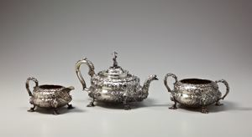

Hyam Hyams, Tea Set, 1825-1826. Silver. Teapot: 7 x 11 1/2 x 6 1/2 in.

Theme #2: Poverty and Prosperity
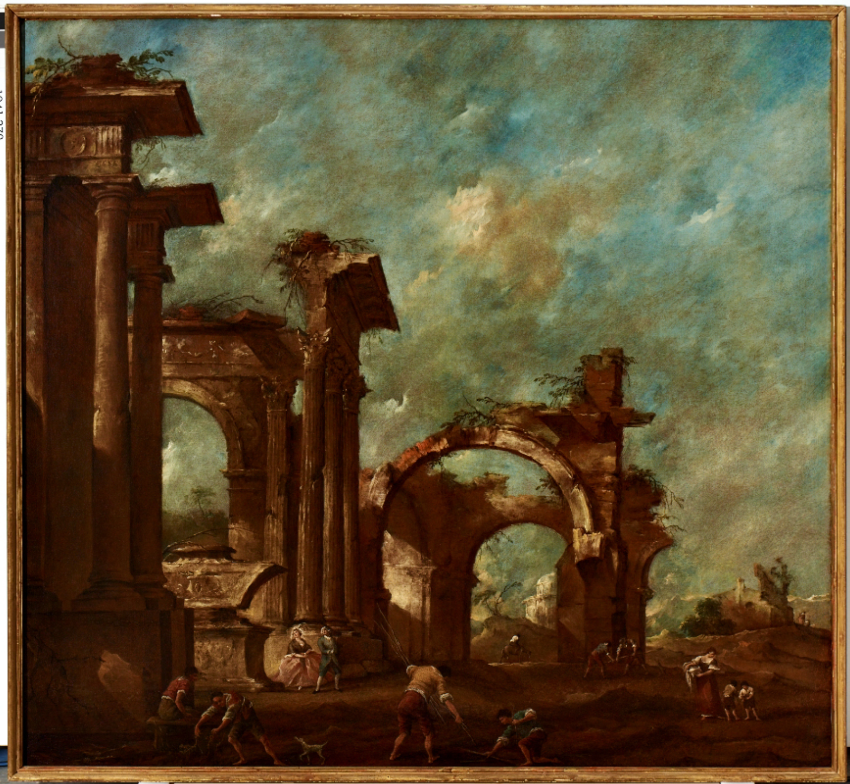

Francesco Guardi, landscape with Ruins, Italy, 18th Century. Oil on Canvas, 67 3/8 in. x 72 1/2 in.

Theme #3: Objective Knowledge and Subjective Vision
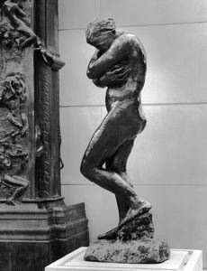

Auguste Rodin, Eve, France, 1881. Bronze. 68 in. x 23 3/4 in. x 30 in.

Theme #4: States and Other Institutions of Power

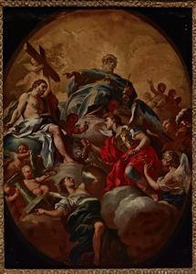
Francesco Solimena, Holy Trinity Adored by St. Michael, Italy, 1695-1700. Oil on canvas. 27 in. x 20 in.

Theme #5: Individual and Society

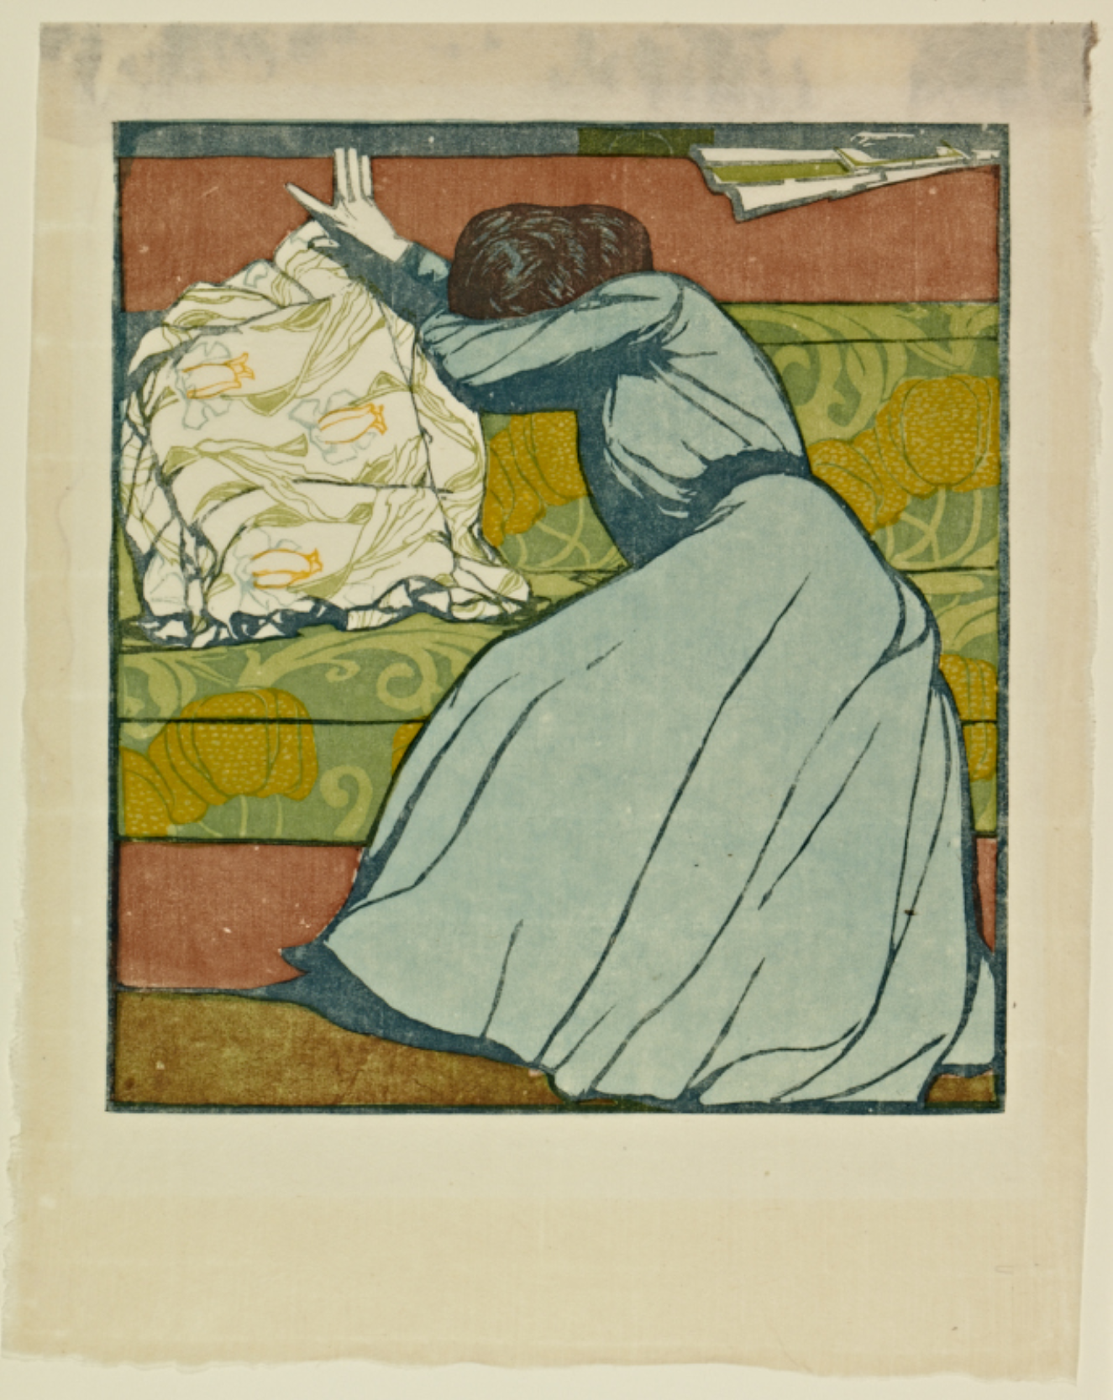

Max Kurzweil, The Cushion (Der Polster), Vienna, 1903. Color woodcut. 15 7/16 x 12 3/16 in.

